

# Archaeological Survey – Field H1550 (N) & (S)

**Description of works:**

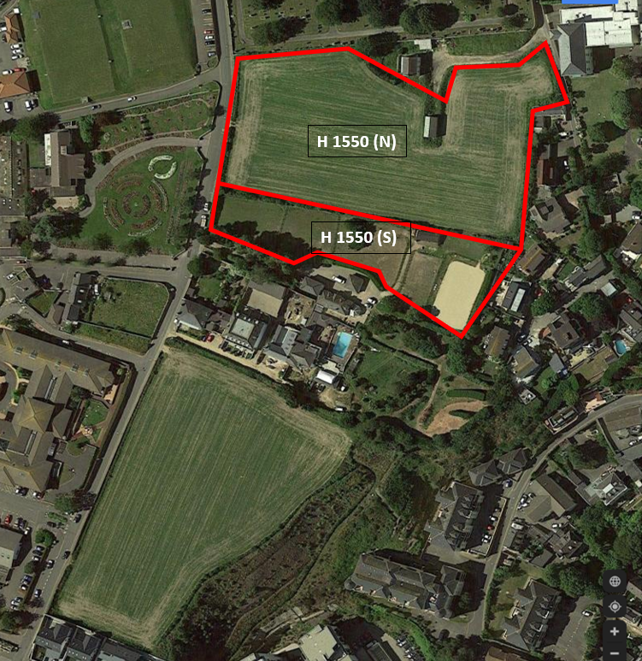We would like to carry out an archaeological survey of the geophysical landscape to determine any areas of historic significance that may require further archaeological investigation. The archaeologists will also be providing a watching brief on any excavations carried out during the geotechnical site investigation works to observe if there are unearthed areas of historic significance.

Fig. 01

**Plant and Equipment:**

The planned equipment of use will be a ground penetrating radar capable of detecting materials up to 5 metres in depth.

**Duration:**

The duration of the survey in field H 1550 (N) will take approx. 1 week.

The duration of the survey in field H 1550 (S) will take for approx. 1 week.

The proposed survey working times are between 08:00AM and 17:00PM Monday to Friday.

No works will be undertaken on Saturdays and Sundays

ROKFCC have already alerted the neighbours to the survey works and they will continue to keep all parties involved informed throughout the process and do everything they can to minimise disruption.

**Number of personnel:**

There will be 1 nr. personnel attending.